APA Format: Using Tables and Figures

This handout is based on the Publication Manual of the American Psychological Association, Seventh Edition, 2019. See Section 7.20: Table Checklist (p. 207) and Section 7.35: Figure Checklist (p. 232) for specific recommendations.

Tables
The purpose of tables is to present data in the paper, especially directly relevant information that would be hard to explain in written text.
You can produce tables in research papers in three ways:
1.) Create a table with original data.
2.) Design a table from published data you have researched.
3.) Copy a table you have found in your research.

Figures
The purpose of figures is to present visual information directly relevant to the content of the paper, especially information that would be hard to explain in written form. Data for the figure may be based on your own original research or come from published sources.
A variety of figures can be used to clarify ideas:
- Bar graphs
- Diagrams, maps, and drawings
- Line graphs
- Photographs
- Charts (pie charts, flow charts, organizational charts)

Shared Conventions
- Both tables and figures appear flush with the left margin.
- Both can be placed after the References page or be embedded in the body of your paper. If embedded, place the table/figure after the paragraph in which it is mentioned. Consult your instructor for preferred placement.
- Refer to both within the text of your paper. Provide a callout within the text of the paper at the point where you wish the reader to refer to the table/figure, like this: (see Table 1).
- Both are numbered using Arabic numerals consecutively throughout the paper. Table/figure numbers appear above the table/figure title, are flush left, and are boldfaced. When a paper contains both tables and figures, number each separately, like this: Table 1, Figure 1, Table 2. (See p. 41 for guidance on numbering when appendices are used).
- The title should concisely describe the content of the information on display. The title is italicized, appears flush left, and appears beneath the table/figure number, with the first word and all important words capitalized (e.g., Predictors of Reaction Times).
- Notes can include explanations of abbreviations, probability information, keys for superscripts, and copyright information among other information. If you are not using original data, a source citation must be included below the table/figure and on the References page.

Conventions Unique to Tables
- Tables are characterized by a row-column formation.
- Horizontal lines are placed above and below the table, as well as below all column headings. Vertical lines are not used. See p. 205 of the Publication Manual for more guidance.

Conventions Unique to Figures
- APA uses a sans serif font with a point size of 8–14 for text embedded in figures.
- Legends can appear after the figure or at the bottom of the figure.

Examples:
**Note: Table body is single-spaced to conserve space.**

Table 1
Risk for Lung Cancer in Canadian Women Based on Material Exposure

Environmental exposure | Cases (N) | Controls (N) | Age and province adjusted OR (95% CI)
Asbestos | 4 | 6 | 2.1 (0.6–7.9)
Mineral, cutting, or lubricating oil | 2 | 6 | 1.1 (0.2–5.5)
Pesticides | 11 | 24 | 1.6 (0.7–3.3)
Herbicides | 9 | 18 | 1.6 (0.7–3.8)
Radiation sources | 6 | 9 | 2.0 (0.7–5.9)
Wood dust | 8 | 24 | 1.0 (0.4–2.3)

Note. OR = odds ratio; CI = confidence interval. Adapted from “Risks for Lung Cancer among Canadian Women Who Have Never Smoked,” by J. Hu, Y. Mao, D. Dryer, and K. White, 2002, Cancer Detection and Prevention, 26, p. 134 (https://doi.org/10.1016/S0361-090X(02)00038-7). Copyright 2002 by Elsevier Ltd.

Figure 1
Annual Growth Rate of Electricity Consumption per Capita for Selected Countries between 1971 and 2001
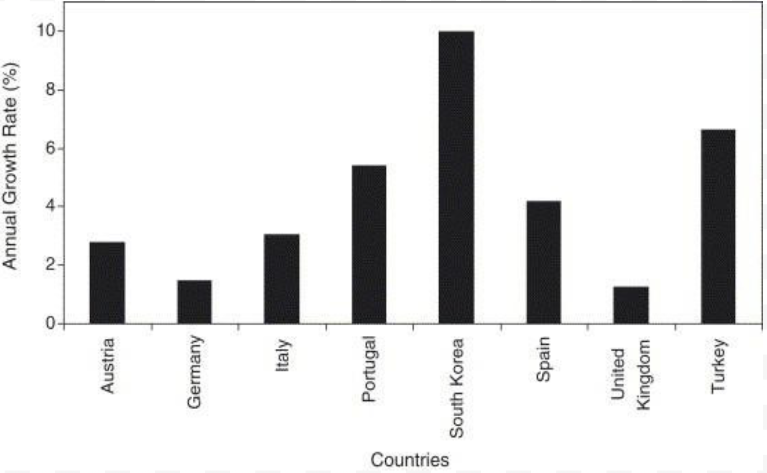

Adapted from “Past, Present, and Future Status of Electricity in Turkey and the Share of Energy Sources,” by H. K. Ozturk, A. Yilanci, and O. Atalay, 2007, Renewable and Sustainable Energy
Reviews, 11, p. 187 (https://doi.org/10.1016/j.rser.2005.01.003). Copyright 2006 by Elsevier Ltd.

